  
  
  
**Principles of Cloud Computing  
CSE3035**

***Lab Fat-  
SET 2*  
Microsoft Azure VM Instance & Round Robin with SJF**

Slot : L11+L12

Name : Kulvir Singh

Register Number : 19BCE2074

**2a) Azure**

**Login to the azure console**

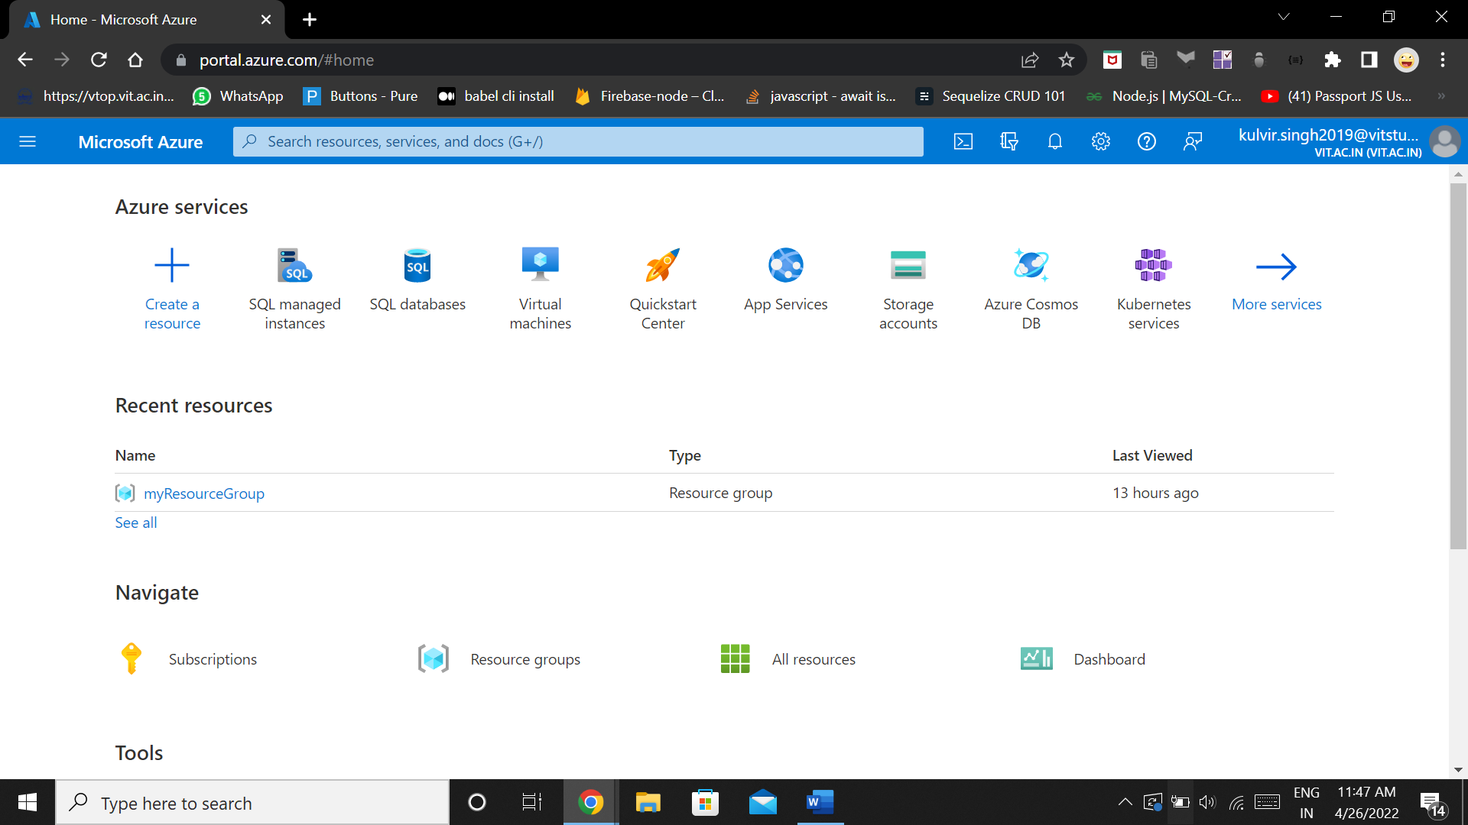

**Search for Virtual Machines**

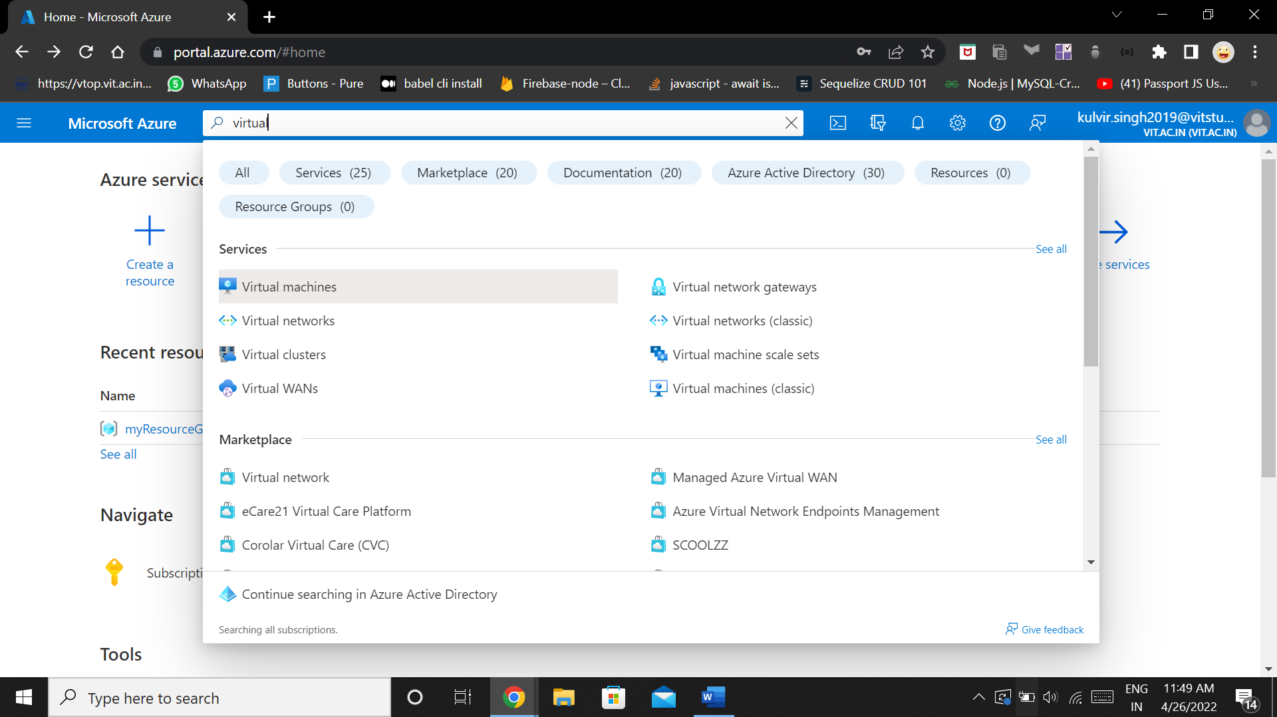

**Create a new virtual machine**

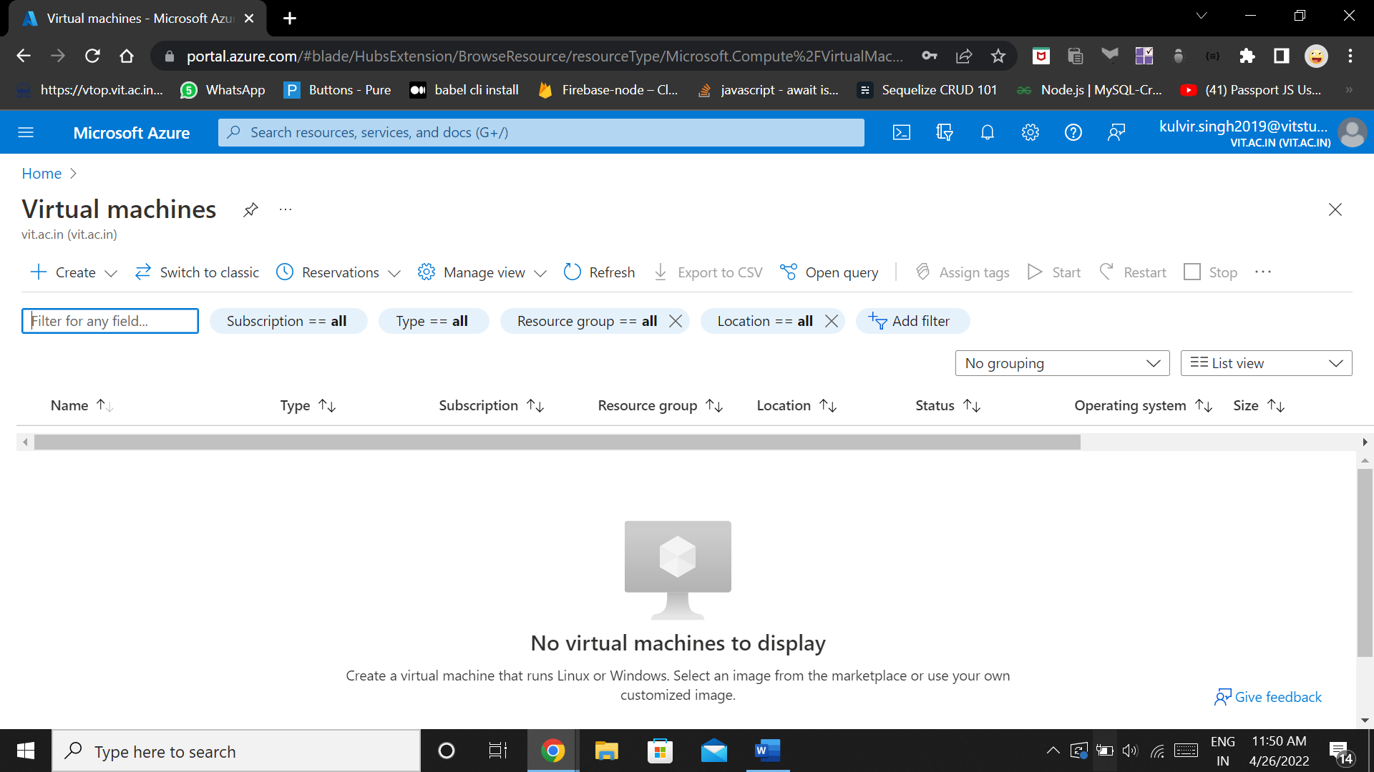

**Configure the virtual machine according to the below configurations**

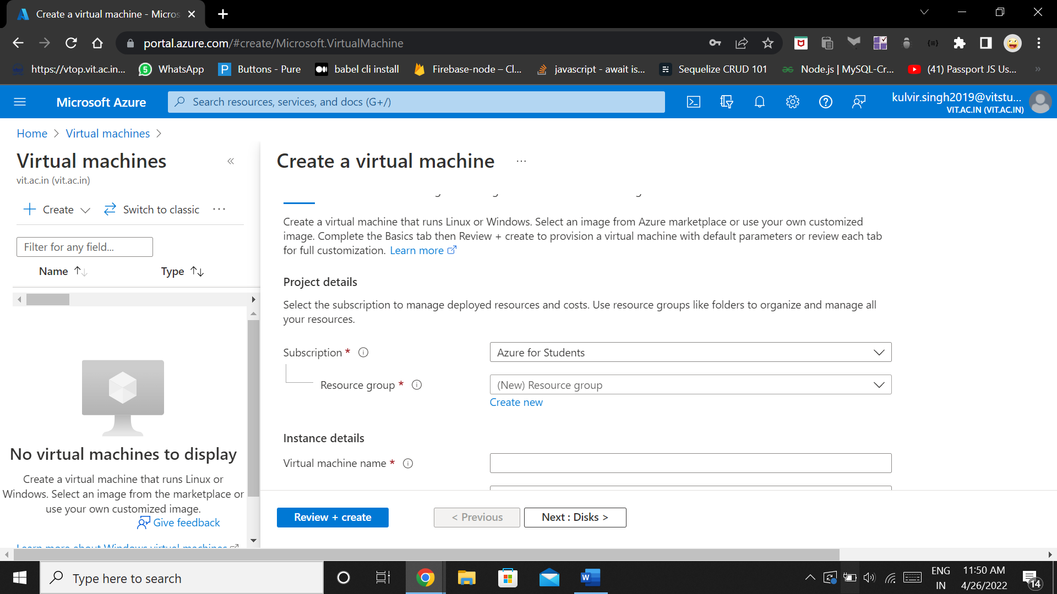

**Configuration :**

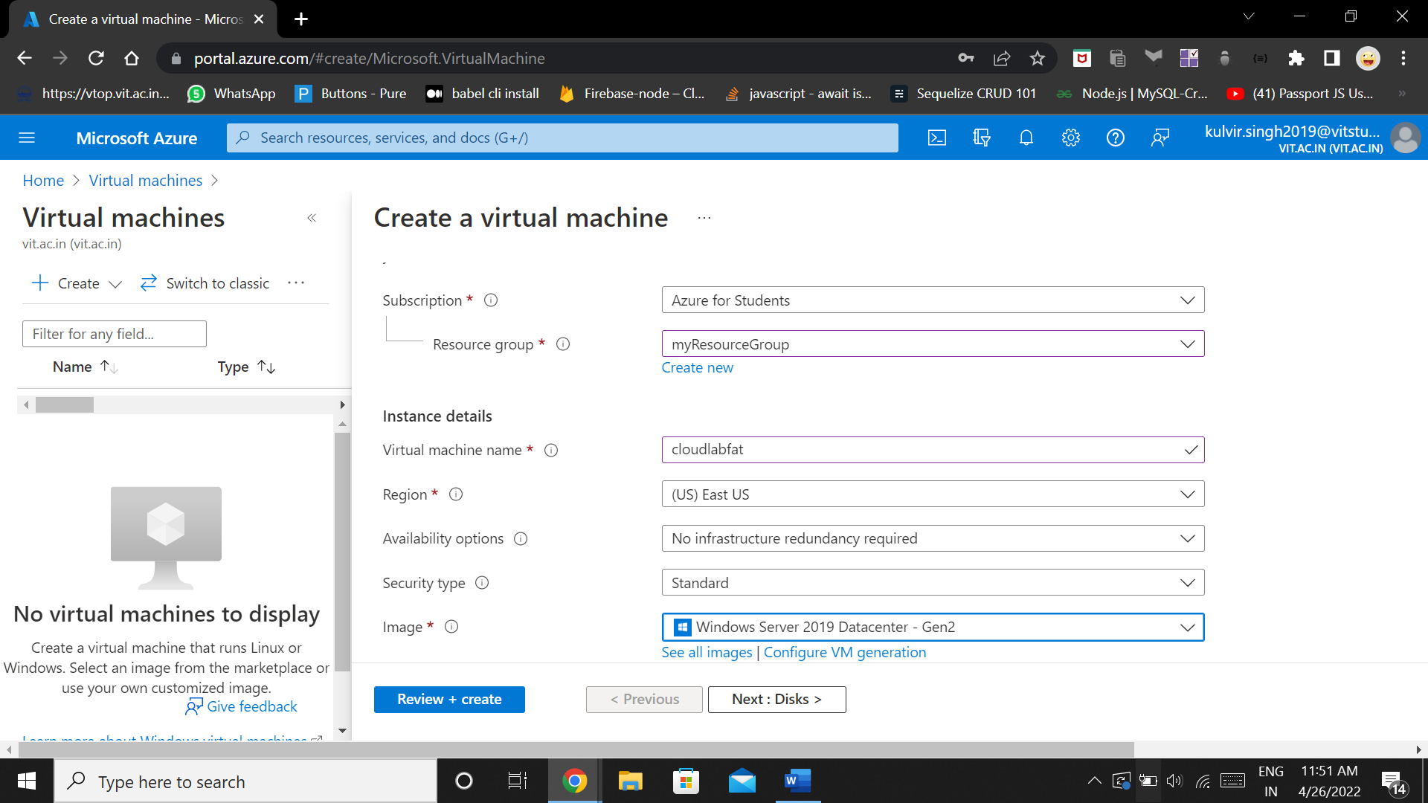

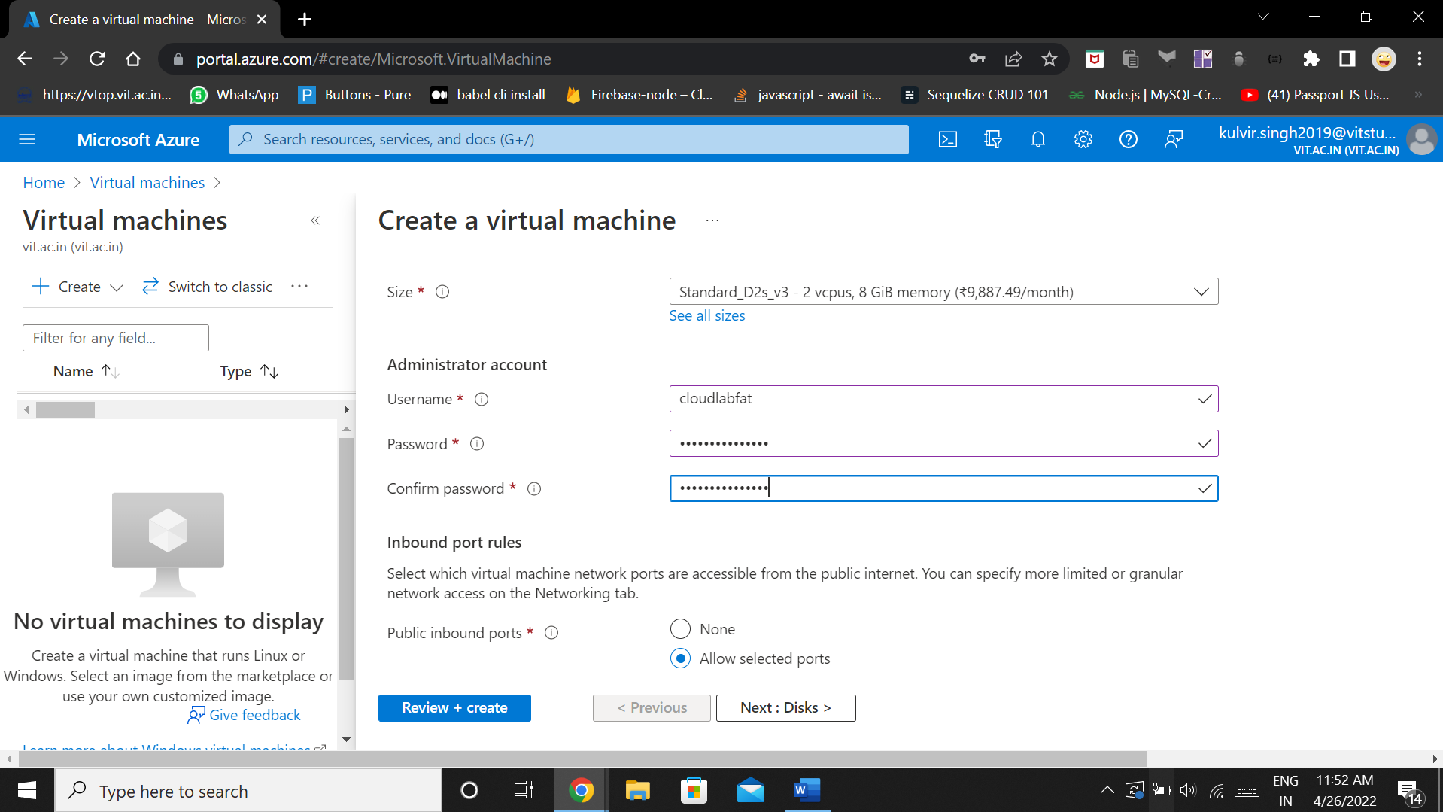

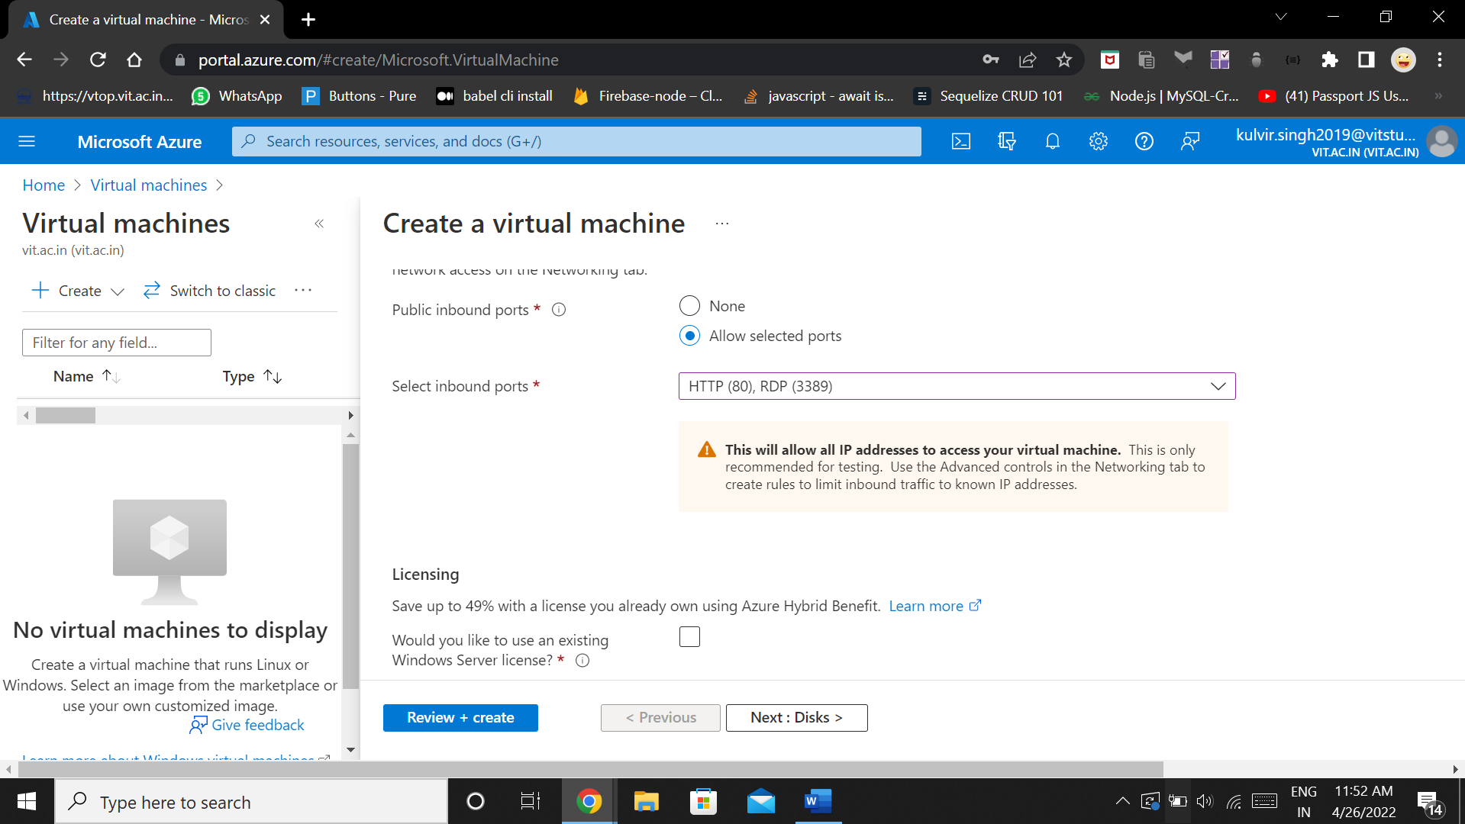

**Disks configuration:**

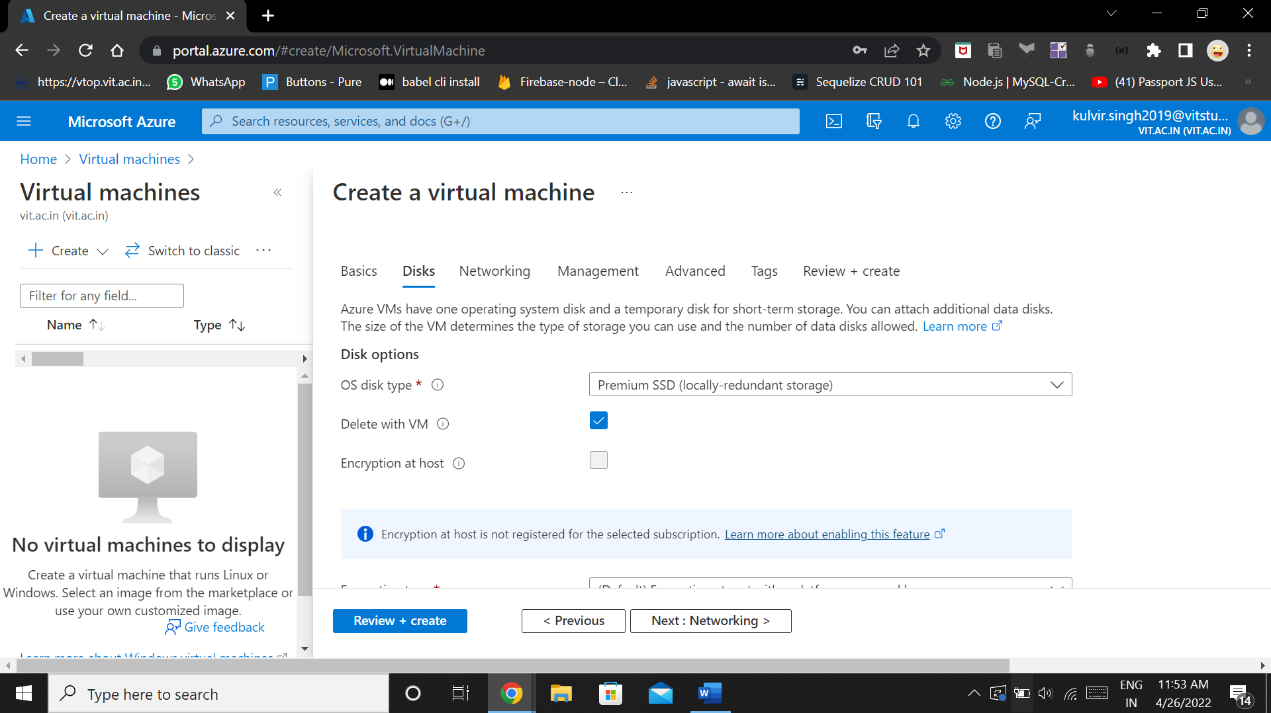

**Networking configurations :**

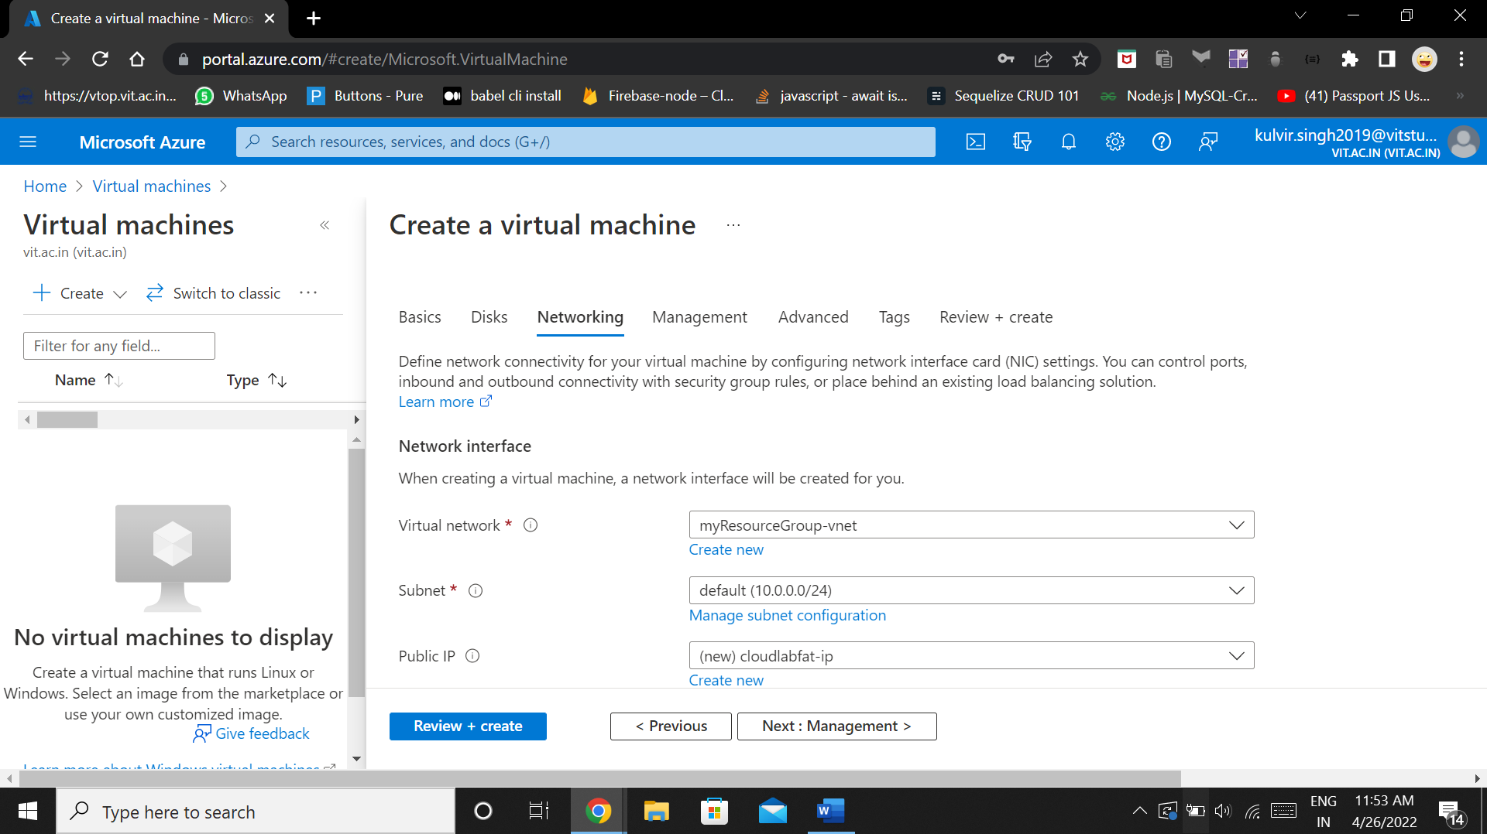

**Management Configurations :**

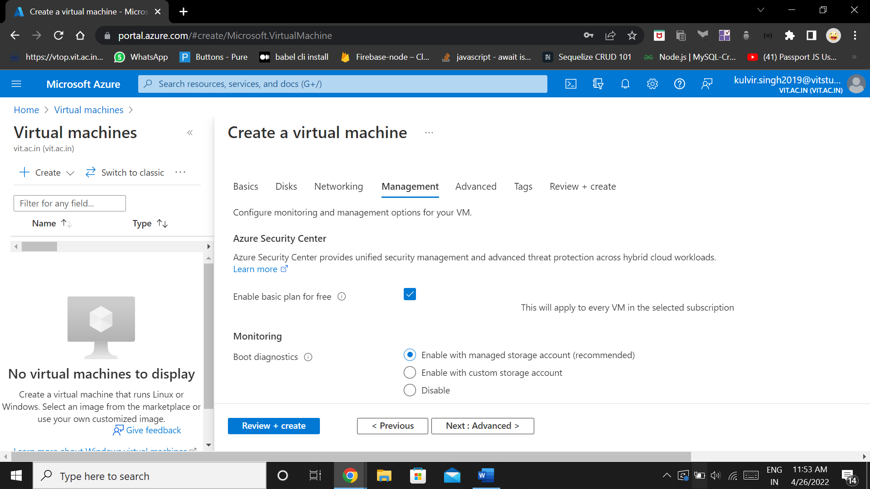

**Reviewing and Creating the virtual machine :**

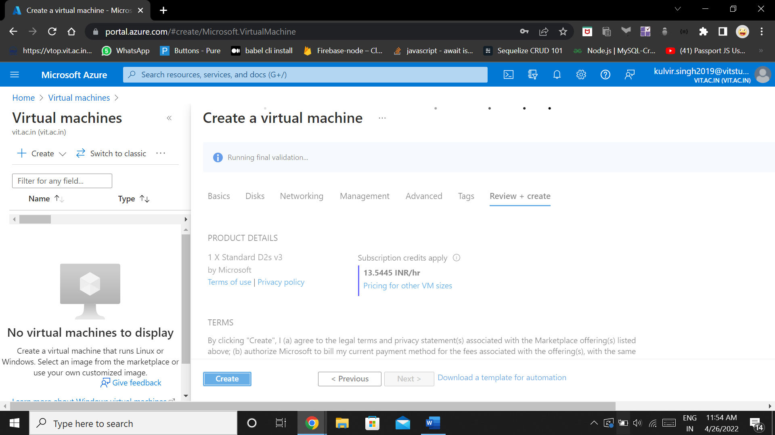

**Deployment in progress :**

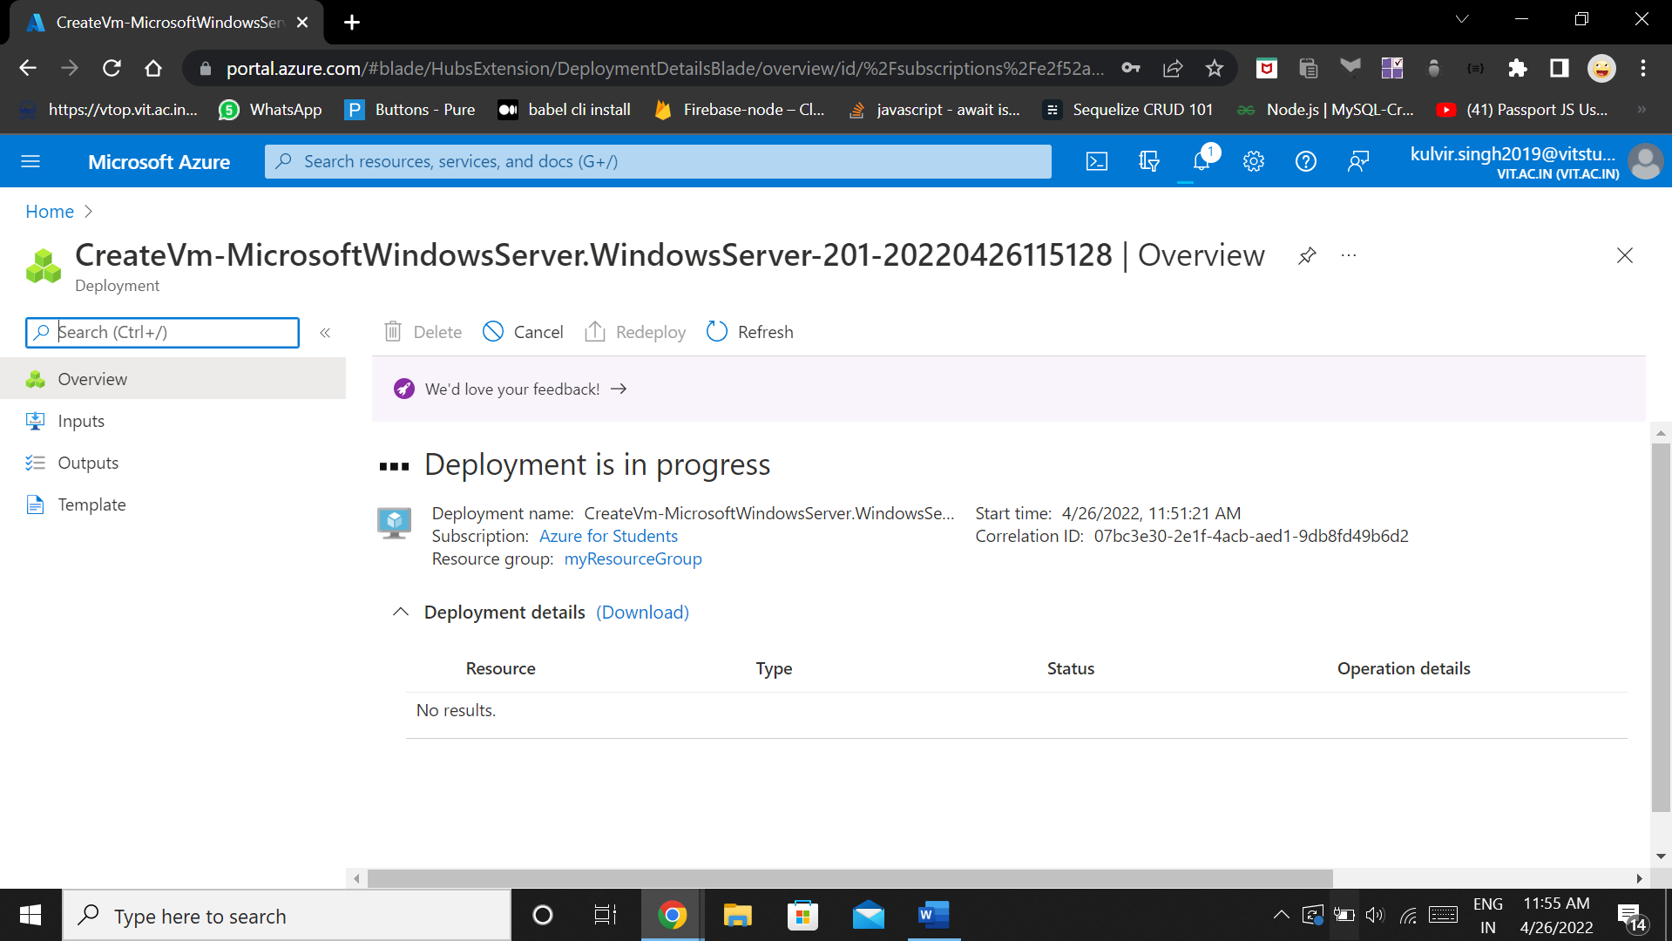

**Finally the VM is created :**

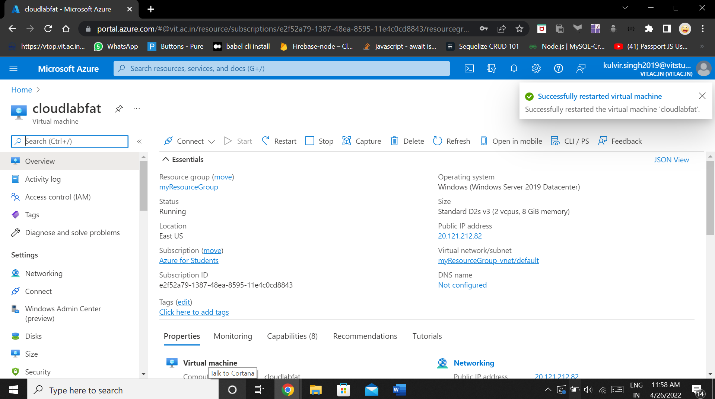

**We now connect our computer and run the instance on our system. For that we download the RDP file**

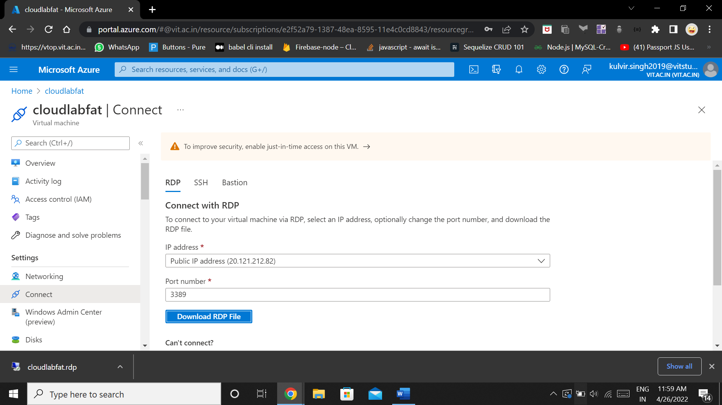

**RDP Connection :**

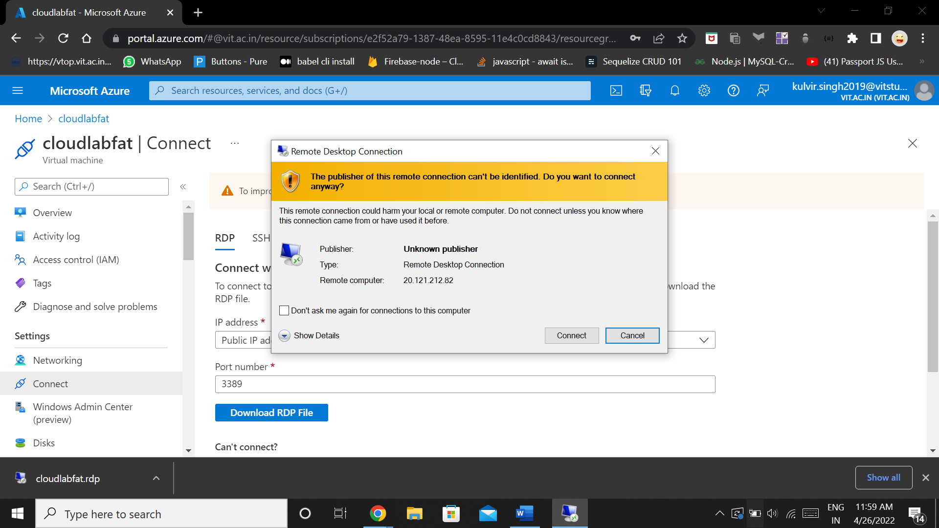

**Enter the credentials :**

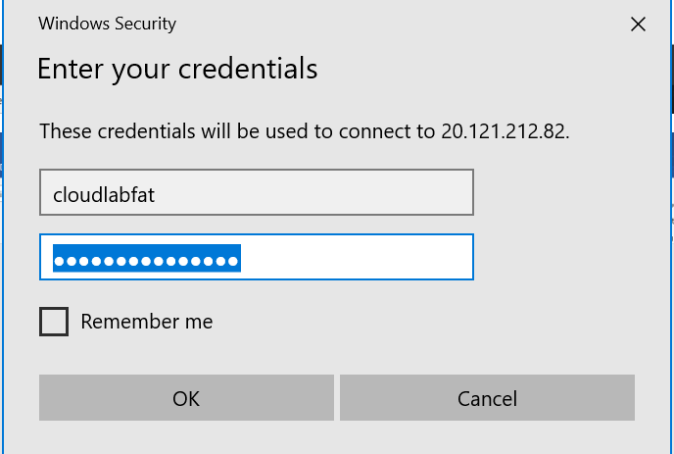

**Running the virtual instance :**

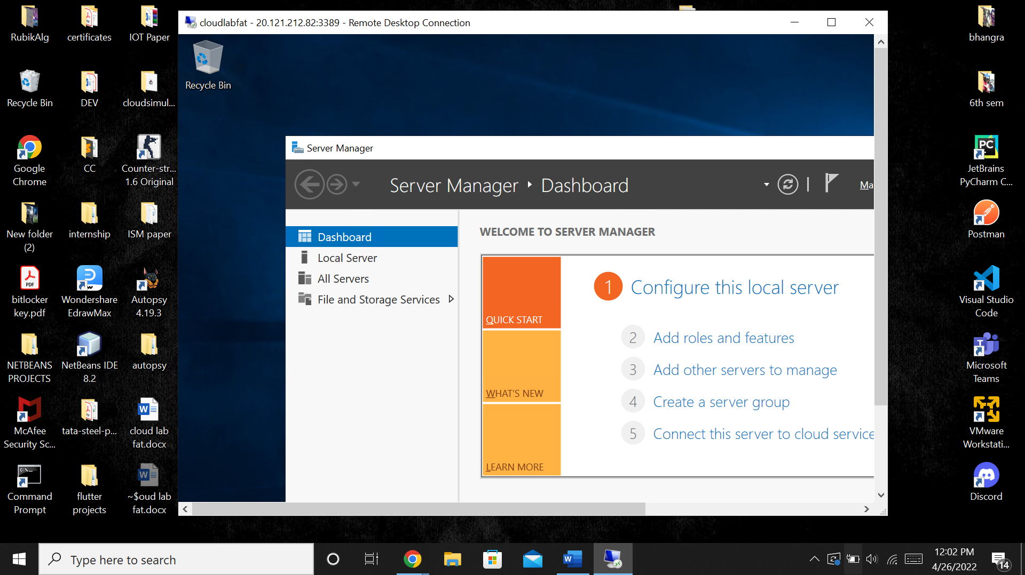

**Now we run the Install-WindowsFeature -name Web-Server -IncludeManagementTools command to setup the instance on our localhost web server**

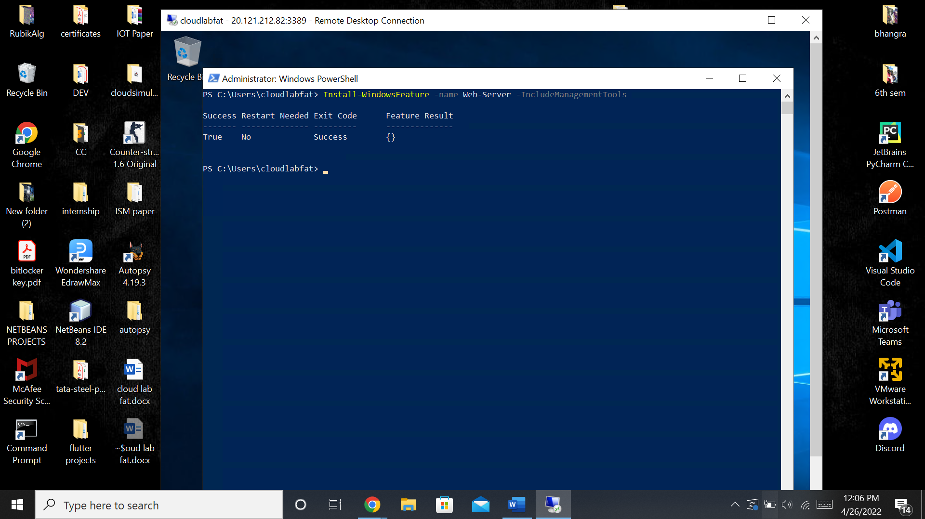

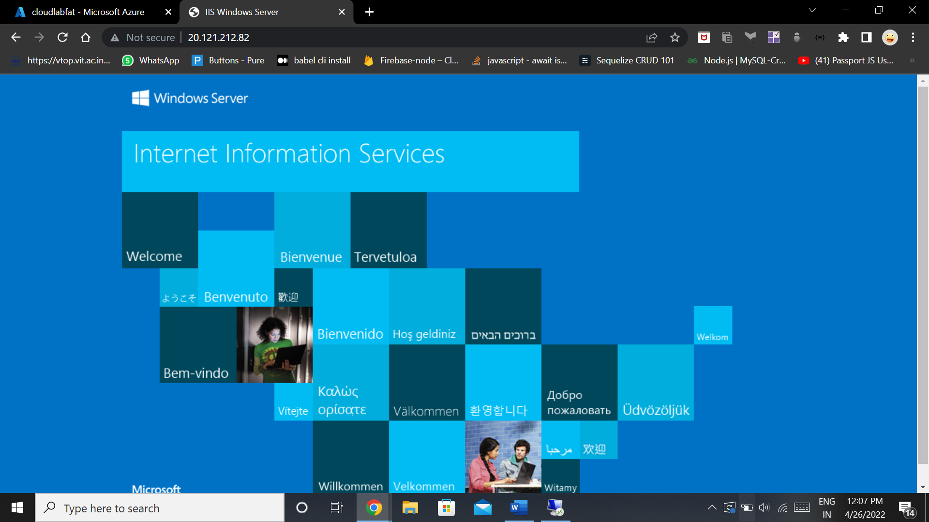

**Question 2b) :**

**Scheduling Round Robin with remaining tasks scheduled by SJF :**

